Supplier name: JDC Building Works Ltd
Publication date: 18/05/2026 (Revision 1 - 02/09/2026)

Commitment to achieving Net Zero
JDC Building Works Ltd. is committed to achieving Net Zero emissions by 2050.

Baseline Emissions Footprint
Baseline emissions are a record of the greenhouse gases that have been produced in the past and were produced prior to the introduction of any strategies to reduce emissions. Baseline emissions are the reference point against which emissions reduction can be measured.

Baseline Year: 2024
Additional Details relating to the Baseline Emissions calculations.
2024 represents JDC Building Works Ltd.’s baseline reporting year and is used as the reference point against which future emissions performance is measured. The baseline includes Scope 1, Scope 2 and the required subset of Scope 3 emissions.
Baseline year emissions:
EMISSIONS | TOTAL (tCO₂e)
Scope 1 | 161.25
Scope 2 | 8.05
Scope 3 (Included Sources) | 576  Business travel, upstream and downstream transportation, waste generated, and employee commuting.
Total Emissions | 745.30

Additional Reporting Year – 2025
Reporting Year: 2025
EMISSIONS | TOTAL (tCO₂e)
Scope 1 | 156.68
Scope 2 | 7.29
Scope 3 (Included Sources) | 562  Business travel, upstream and downstream transportation, waste generated, and employee commuting.
Total Emissions | 725.97

Current Emissions Reporting
Reporting Year: 2026
EMISSIONS | TOTAL (tCO₂e)
Scope 1 | 165.58
Scope 2 | 7.15
Scope 3 (Included Sources) | 590  Business travel, upstream and downstream transportation, waste generated, and employee commuting.
Total Emissions | 762.73

While JDC Building Works Ltd. has already implemented a number of carbon reduction measures, overall emissions have increased slightly in 2026 due to increased workload and operational activity, resulting in higher levels of travel and transportation. Electricity consumption has reduced as office occupancy has decreased, with more employees working remotely and spending less time in the office.

Emissions reduction targets
In order to continue our progress towards achieving Net Zero, JDC Building Works Ltd. has adopted an ongoing commitment to reduce greenhouse gas emissions across its operations.
JDC will continue to target reductions through improved energy efficiency, reduced unnecessary business travel, lower-emission transport and fleet electrification, renewable energy opportunities, and continued environmental management through its ISO 14001 Environmental Management System.
Progress will be monitored annually against JDC’s 2024 baseline emissions of 745.30 tCO2e, with performance reviewed through JDC’s annual carbon reporting and environmental management processes.

We project that carbon emissions will decrease over the next five years to 544.45 tCO2e by 2031. This is a reduction of 26.9%.

Progress against these targets can be seen in the graph below:

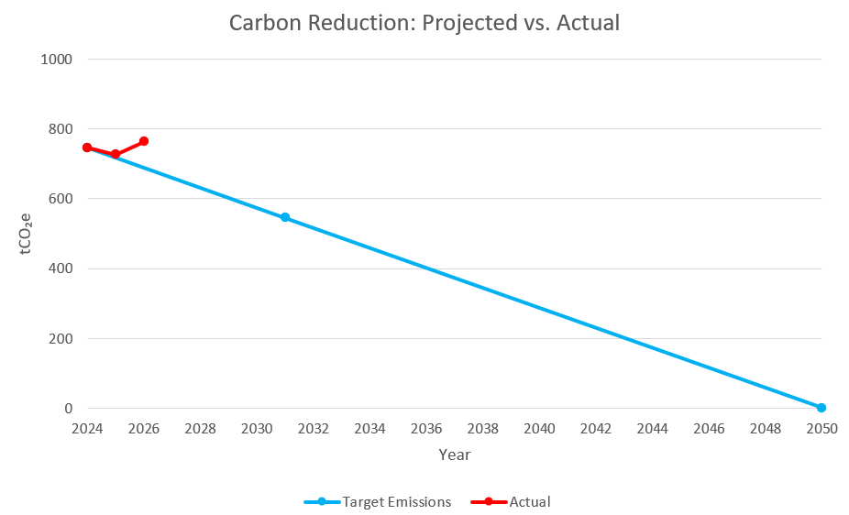

* Note: The increase in actual emissions in 2026 reflects increased business activity and operational growth, including higher levels of travel and transportation associated with a growing workload.

Carbon Reduction Projects
Completed Carbon Reduction Initiatives
The following environmental management measures and projects have been completed or implemented since the 2024 baseline and will remain in effect when performing the contract.
JDC Building Works Ltd. has implemented the following carbon reduction measures:
- achieving and maintaining ISO 14001 Environmental Management System certification;
- upgrading lighting within JDC’s offices and manufacturing facility to energy-efficient LED lighting;
- reducing office electricity consumption through lower office occupancy and increased remote working; and
- reducing unnecessary employee travel where practicable.
The carbon emission reduction achieved by these individual measures has not yet been quantified separately. While JDC’s overall emissions have increased in 2026 due to increased workload, operational activity, travel and transportation, these measures remain in place and continue to support JDC’s environmental and carbon reduction objectives.

Future carbon reduction initiatives
In the future, JDC Building Works Ltd. intends to implement further carbon reduction measures including:
- reducing unnecessary employee and business travel;
- progressively transitioning towards an electrified and lower-emission company fleet;
- investigating the installation of solar photovoltaic panels on the workshop roof to reduce reliance on grid electricity; and
- continuing to monitor energy use, travel, transport and operational emissions through JDC’s ISO 14001 Environmental Management System.
These initiatives will support JDC Building Works Ltd.’s continued progress towards achieving Net Zero emissions by 2050

Declaration and Sign Off
This Carbon Reduction Plan has been completed in accordance with PPN 006 and associated guidance and reporting standards for Carbon Reduction Plans.
Emissions have been reported and recorded in accordance with the published reporting standard for Carbon Reduction Plans and the GHG Reporting Protocol corporate standard and uses the appropriate Government emission conversion factors for greenhouse gas company reporting.
Scope 1 and Scope 2 emissions have been reported in accordance with SECR requirements, and the required subset of Scope 3 emissions have been reported in accordance with the published reporting standard for Carbon Reduction Plans and the Corporate Value Chain (Scope 3) Standard.
This Carbon Reduction Plan has been reviewed and signed off by the board of directors (or equivalent management body).

Signed on behalf of the Supplier:


Frank McGurk
Director
Date:02/09/2026 (Revision 1 - 02/09/2026)

